| PROJECT INFORMATION | | | |
| --- | --- | --- | --- |
| **Report Description:** | Timeline | | |
| **Professor:** | Prof. [Gady Agam](mailto:agam@iit.edu) | **Tools used/work done:** | 1. Preprocessed 33 sub. 2. Labeling - In progress |
| **Report prepared by:** | [Noviya Balasubramanian](mailto:nbalasubramanian@hawk.iit.edu) |
| **HAWK ID:** | A20541236 |
| **Report no:** | 7 | **Report Date:** | 10/4/2024 |

**Timeline:**

1. **First 6 Weeks: Literature Review, Data Access, Preprocessing, Problem Statement Definition**
2. **Week 7 (Oct 4): Data Preprocessing Completion, MARA Exploration in MATLAB - Completed for 33 subjects**
3. Week 8 (Oct 11): Labeling, Feature Extraction and Classification - Initial Training
4. Week 9 (Oct 18): Classifier Selection and Initial Training
5. Week 10 (Oct 25): Classifier Optimization and Validation
6. Week 11 (Nov 1): Multimodal Analysis
7. Week 12 (Nov 8): Fusion or Comparison Analysis Scope
8. Week 13 (Nov 15): Final Testing
9. Week 14 (Nov 22): Model Evaluation
10. Week 15 (Nov 29): Report Preparation (Buffer)
11. Week 16 (Dec 6): Report Submission

**Topic: *Classification of Cognitive States Using EEG and Physiological Signals: Impasse, Aha!, Uncertainty***

**As planned:  
Cleaned and processed the EEG data for 33 subjects.**

**[For subjects with more than one EEG reading is on hold.]**

**Range - 0.5 to 50**

* **Used MARA for easy classification**

MARA is an automated and efficient classifier that utilizes a binary linear classifier to determine whether an IC is an artifact or a neuronal signal, thereby enabling researchers to retain or reject it.

[1] Kyriaki, Konstantina, Dimitrios Koukopoulos, and Christos A. Fidas. "A Comprehensive Survey of EEG Preprocessing Methods for Cognitive Load Assessment." IEEE Access (2024).

MARA is an automated and efficient classifier that utilizes a binary linear classifier to determine whether an IC is an artifact or a neuronal signal, thereby enabling researchers to retain or reject it. MARA has demonstrated a strong performance online and in various experimental contexts. It handles effectively different types of artifacts [63], particularly myogenic artifacts [3]. After feature selection, classification was performed using the K-Nearest Neighbors (KNN) and Support Vector Machine (SVM) algorithms. A remarkable classification accuracy of 98.79% was cited, significantly higher than the classification based on features from the time, frequency, or time-frequency domains.

EEGLAB authors suggest running ICA twice, first to reject epochs based on the IC time courses, second to obtain a good ICA decomposition for the cleaner data. [I used MARA to run ICA twice for the subjects and mark them for rejection]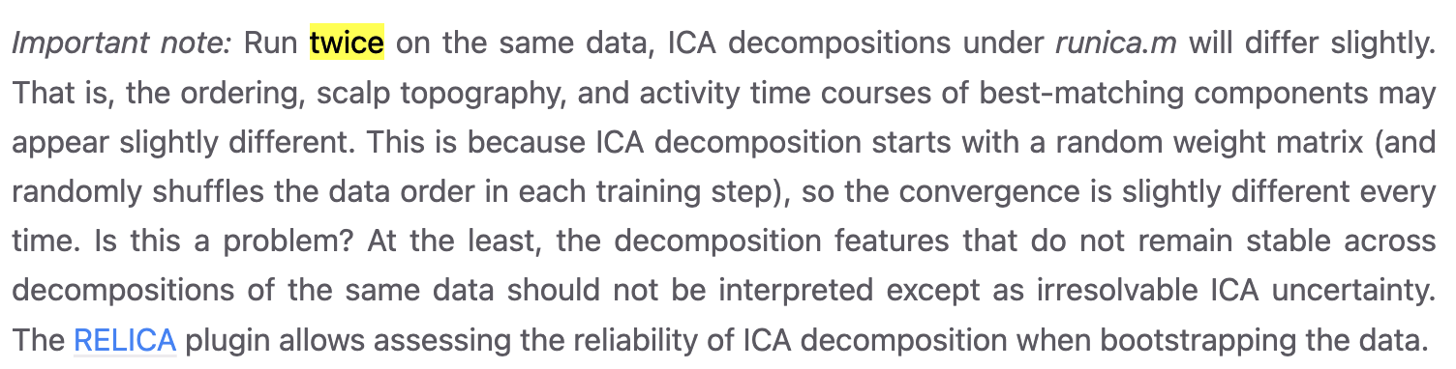

For artifact removal used the following probability to reject:

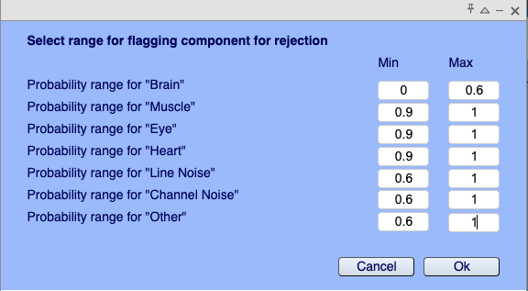

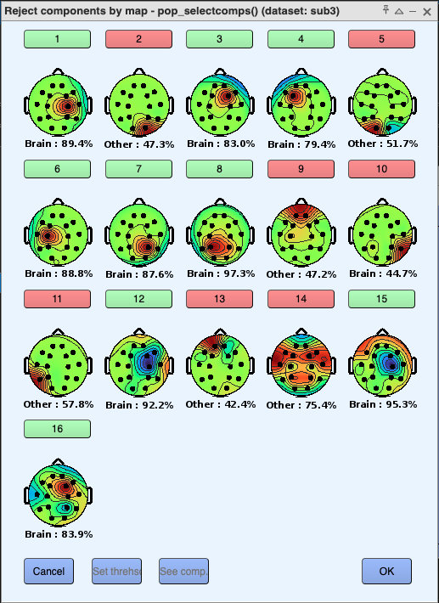

**Labeling the data:**

1.“Aha!” State:

Description: Triggered when participants click on a label violation.

Relevant Timestamps:

TagHandMenuPumpTime: Initial hand menu interaction.

TagClickTime: The moment of clicking the violation.

TaggingTime: Completion of the tagging process.

Time Frame: 1-2 seconds before and after TagHandMenuPumpTime.

2.“Reevaluation” State:

Description: Activated when participants detag a previously labeled violation.

Relevant Timestamps:

DetagHandMenuPumpTime: Initial interaction for detagging.

DetagClickTime: The moment of clicking to detag.

DetaggingTime: Completion of the detagging process.

Time Frame: 1-2 seconds before and after DetagHandMenuPumpTime.

4.“Walking state”:

Description: Covers cases not classified under the above categories.

Time Frame: 5-10 seconds where no specific tagging or detagging occurs, especially during idle or unrelated tasks.

**5. Impasse**

Description: Triggered when participants mark but do not label an object as a violation.

Relevant Timestamp:

BTButtonPressTime: Used for marking answers.

Time Frame: 1-2 seconds before and after BTButtonPressTime.

* BTButtonPressTime
* **Finish list >** BTButtonPressTime

**Feature Classification for Initial training:**

[2]Y. Narayan, "Hand Motion Identification Based on EEG Signals Classification," 2021 2nd Global Conference for Advancement in Technology (GCAT), Bangalore, India, 2021, pp. 1-7, doi: 10.1109/GCAT52182.2021.9587556.

Variance: Calculated using a 500 ms window with a 492 ms overlap, capturing the signal’s variability.

Band Power: Extracted from alpha and beta frequency bands to evaluate brainwave activity.

Minimum Energy: Estimates the signal-to-noise ratio by determining the least energy required for accurate signal representation.

Time Sequence Complexity: Measures the complexity and dynamic nature of EEG signal sequences.

Roughness of Fractal Dimension: Utilizes Higuchi’s algorithm to quantify the fractal and irregular properties of the signal.

Hjorth Parameters:

Activity: Represents the mean power (variance) of the signal.

Mobility: Measures the rate of change in signal frequency.

Complexity: Quantifies deviations from simple sine waves in frequency changes.

Barlow Parameters:

Mean Amplitude: Captures the average amplitude of the signal.

Mean Frequency: Represents the average frequency across the signal.

Spectral Purity Index: Measures the signal’s irregularity, with a maximum value of one.

Adaptive Autoregressive Parameters: Models variations in EEG signals over time, adding depth to the feature set for improved classification accuracy.

**Questions:**

* **How to consider the Impasse state**
* **What to do when there are more than one EEG reading**